**Application Services Summary**

**What is SQS?**

* Amazon SQS is a web service that gives you access to a message queue that can be used to store messages while waiting for a computer to process them.

**SQS Recap**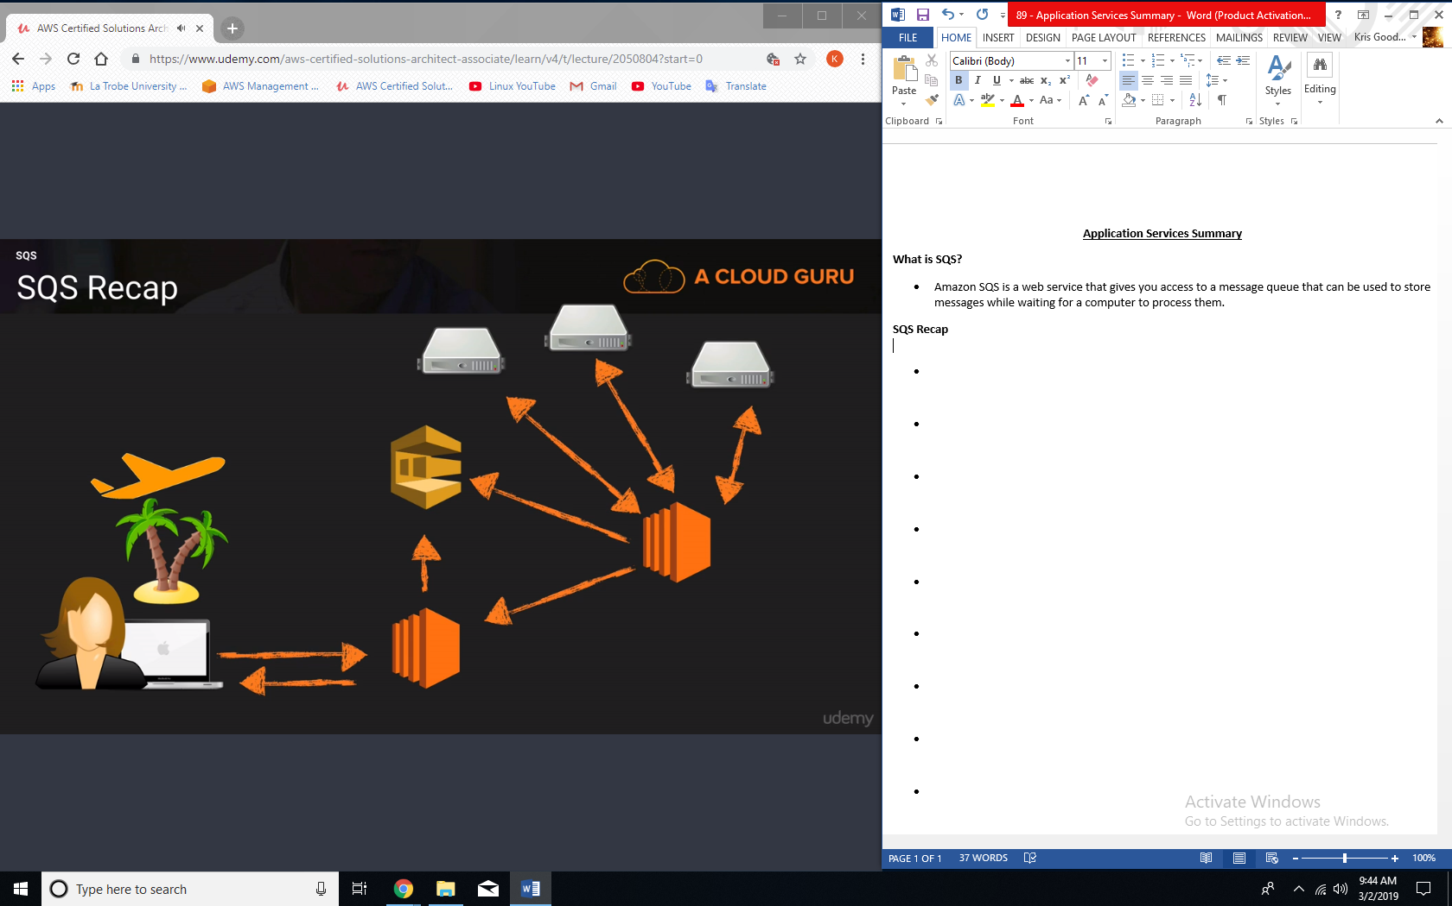

**SQS – Exam Tips**

* SQS is pull based, not push based.
* Messages are 256 KB in size.
* Messages can be kept in the queue from 1 minute to 14 days, the default is 4 days.
* Visibility Time Out is the amount of time that the message is invisible in the SQS queue after a reader picks up that message. Provided the job is processed before the visibility time out expires, the message will then be deleted from the queue. If the job is not processed within that time, the message will become visible again and another reader will process it. This could result in the same message being delivered twice.
* Visibility time out maximum is 12 hours.

**SQS Key Facts:**

* SQS guarantees that your messages will be processed at least once.
* Amazon SQS long polling is a way to retrieve messages from your Amazon SQS queues. While the regular short polling returns immediately, even if the message queue being polled is empty, long polling doesn’t return a response until a message arrives in the message queue, or the long poll times out.
* Queues can either be standard or FIFO.

**SWF vs SQS:**

* SQS has a retention period of 14 days, SWF is up to 1 year for workflow executions.
* Amazon SWF presents a task-oriented API, whereas Amazon SQS offers a message-oriented API.
* Amazon SWF ensures that a task is assigned only once and is never duplicated. With Amazon SQS, you need to handle duplicated messages and may also need to ensure that a message if processed only once.
* SWF keeps track of all the tasks and events in an application. With SQS, you need to implement your own application-level tracking, especially if your application uses multiple queues.

**SWF Actors:**

* Workflow starters – an application that can initiate a workflow. Could be your e-commerce website when placing an order or a mobile app searching for bus times.
* Deciders – control the flow of activity tasks in a workflow execution. If something has finished in a workflow (or fails) a decider decides what to do next.
* Activity workers – carry out the activity tasks.

**SNS Subscribers**

* HTTP
* HTTPS
* Email
* Email-JSON
* SQS
* Application
* Lambda

**SNS vs SQS:**

* Both messaging services in AWS.
* SNS – push.
* SQS – pull.

**What is Elastic Transcoder?**

* Media transcoder in the cloud.
* Convert media files from their original source format into different formats that will plat on smartphones, tablets, PCs, etc.
* Provides transcoding presets for popular output formats, which means that you don’t need to guess about which settings work best on particular devices.
* Pay based on the minutes that you transcode and the resolution at which you transcode.

**Core Kinesis Services:**

* Kinesis Streams  
  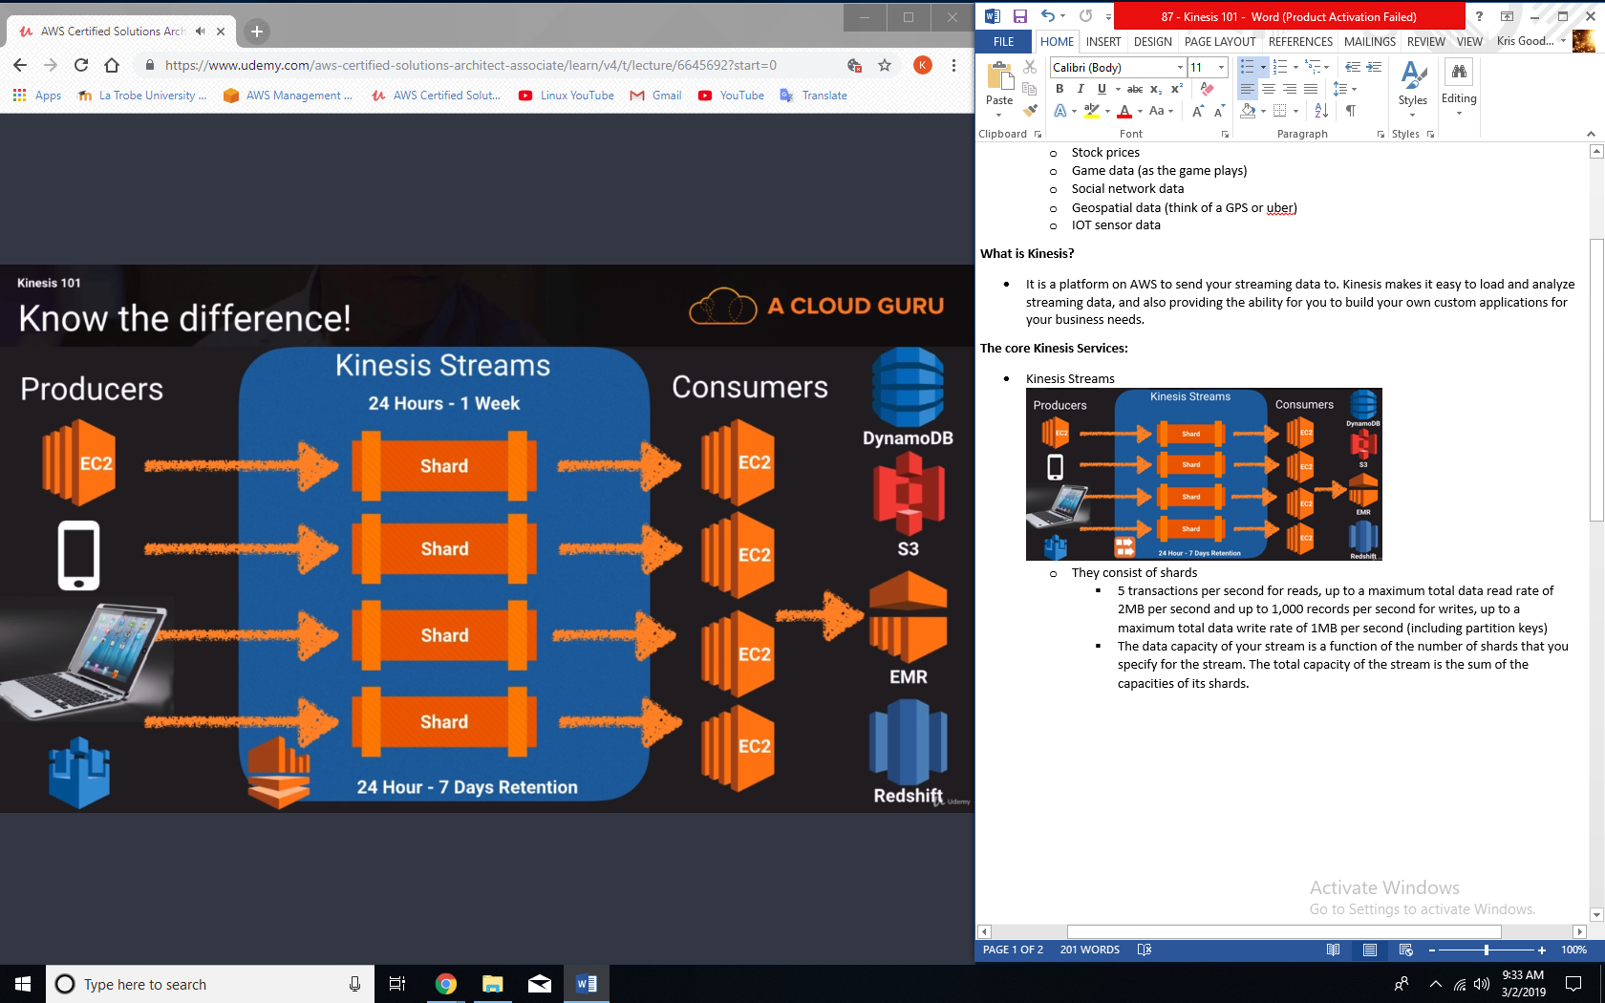
* Kinesis Firehose  
  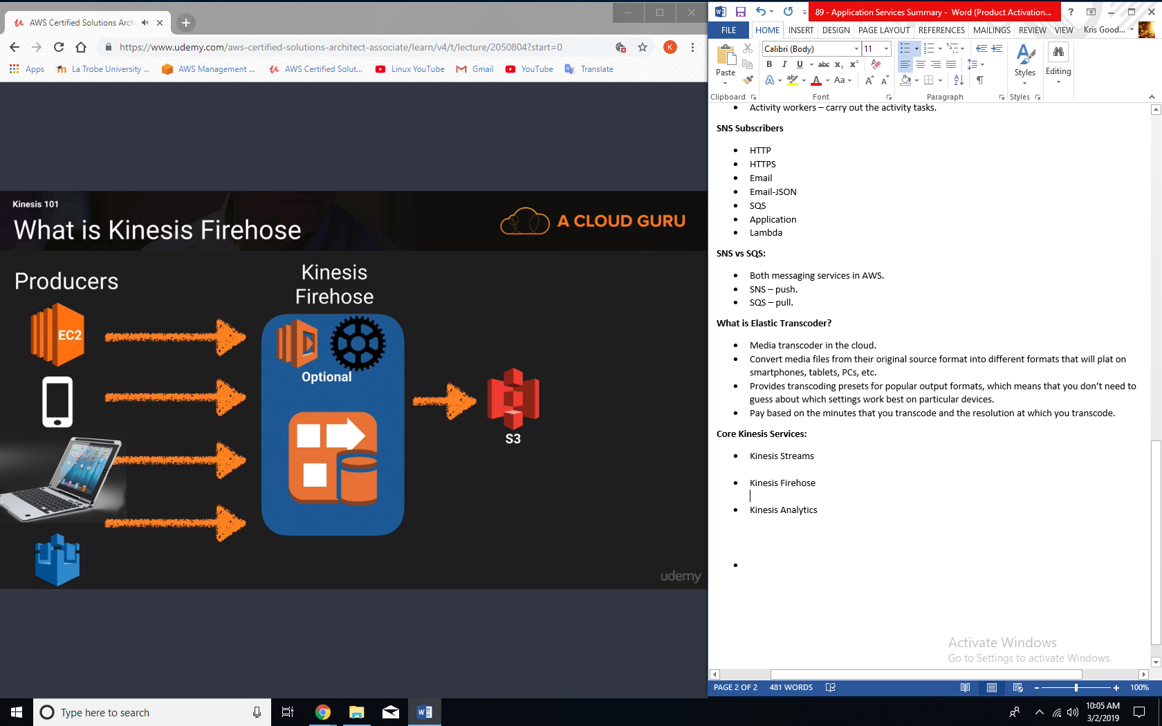
* Kinesis Analytics  
  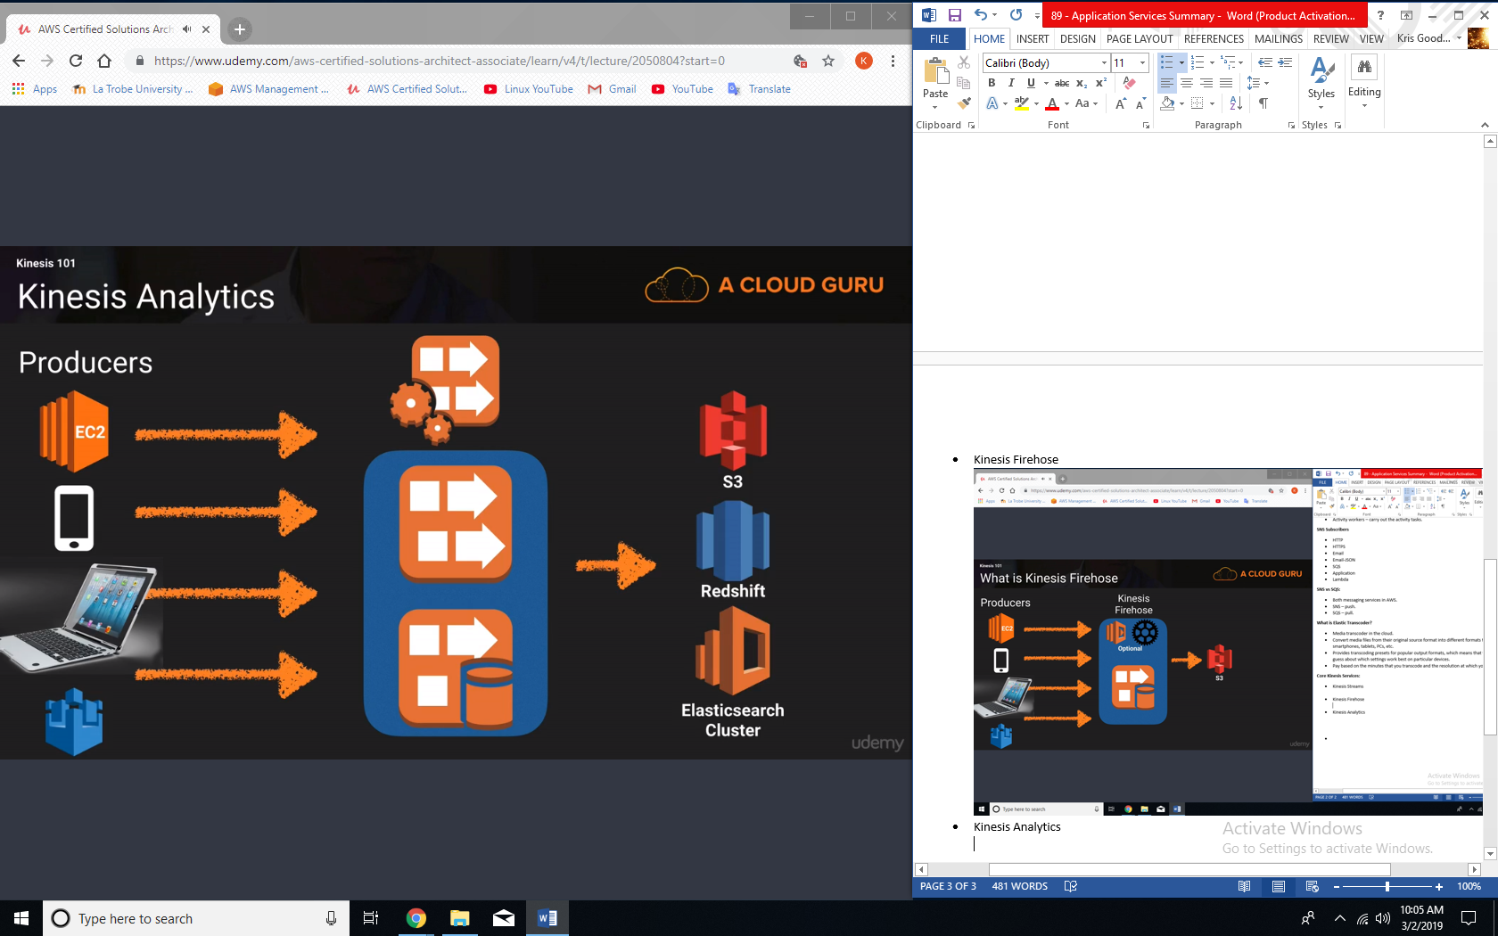

**Kinesis - Exam Tips:**

* Know the difference between kinesis Streams and Kinesis Firehose. You will be given scenario questions and you must choose the most relevant service.
* Understand what Kinesis Analytics is.